***Directions: Provide a snippet of each figure in the tutorials below.***

**Tutorial 1-1 (Pg. 8):**

1. Figure 1-3:

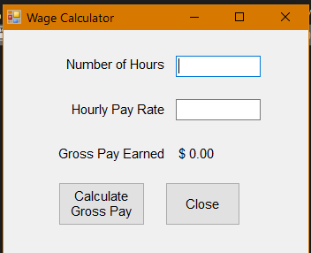

**Tutorial 1-2 (pg. 10):**

1. Figure 1-6:

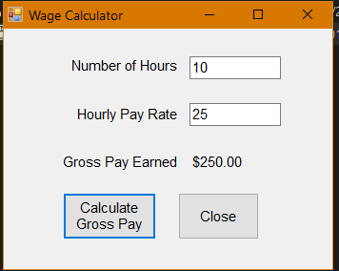

**Tutorial 1-3 (pg. 12):**

1. Figure 1-7:

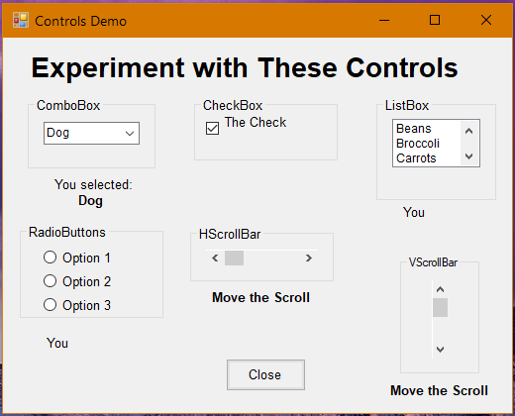

***Directions: Provide a snippet of the Toolbox, Designer Window, Solution Explorer, and the Properties Window from Visual Studio below:***

**Snippets of Visual Studio**

1. Toolbox

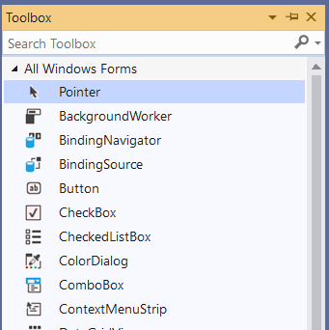

1. Designer Window

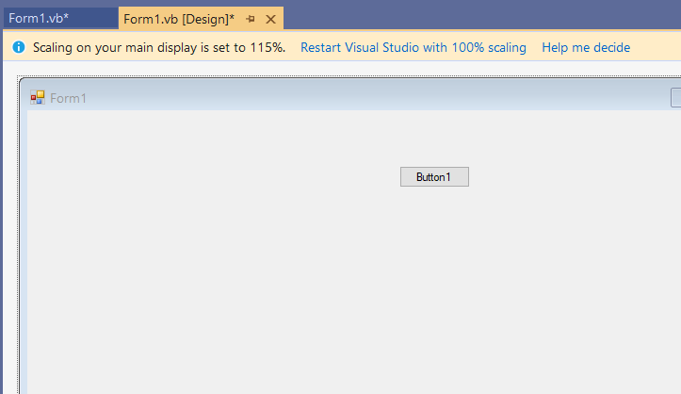

1. Solution Explorer

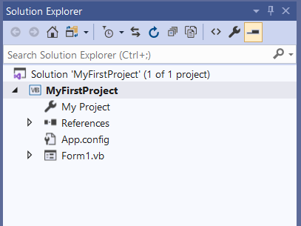

1. Properties Window

